SGroup Intercontinental Academic Exchange Programme
ICON

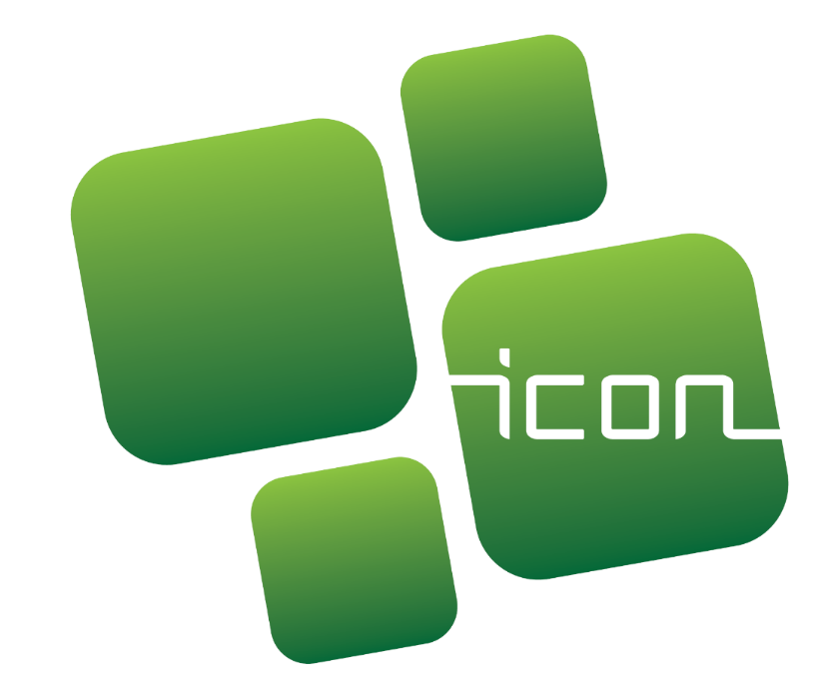

Programme Guide
2024

HEAD OFFICE: RUA DO CAMPO ALEGRE 820, 4150-171 PORTO PORTUGAL
SGROUP@SGROUP-UNIS.EU | HTTPS://SGROUP-UNIS.EU/ | (+351) 967906060 | (+351) 932006852

Index
1. The ICON programme 2
1.1. Description 2
1.2. aims and objectives 2
2. Call for applications for 2024 3
2.1. Call period 3
2.2. Grants distribution 4
2.3. Redistribution of grants 4
3. Applications 4
3.1. Eligibility criteria 4
3.2 Evaluation and Selection criteria (weighting factors) 5
3.3. Preparing an application 6
3.4. Mobility period and duration 7
3.5. Host institutions 8
3.6. Submission of applications 8
3.7. Selection and communication of results 9
4. Functioning of ICON mobilities 9
4.1. Practical arrangements before departure 9
4.2. During the mobility 9
4.3. After the mobility 10
4.4. Grant payment 10
4.5. Grant suspension and/or reimbursement 11
5. Contact and support 11

The ICON programme

1.1. Description

The InterContinental Academic Exchange Programme (ICON) finds its origin in long-lasting collaborative links between the SGroup network and its members, and institutions located in strategic regions linked to the SGroup Think Tank Academy. As part of this mobility programme, the academic and administrative staff of full-member European Universities of the SGroup can apply for a SGroup scholarship for a short mobility period in a partner institution of their choice outside Europe and belonging to one of the Think Tank Academy regions: Latin America; China; Africa. The participants and the activity programmes financed by the ICON programme must represent the quality standards and values inherent to the SGroup.

1.2. aims and objectives
The aim of the ICON programme is to promote, facilitate and/or strengthen collaboration between SGroup institutions and their overseas partners, thereby contributing to the SGroup’s commitment to expanding collaboration opportunities in education and research through the transfer of knowledge and the development of strategic alliances.
The strategic objectives of the ICON programme are the following:
- Facilitate collaboration in research and education between the EU and the Think Tank Academy regions (Latin America, China and Africa), as well as between SGroup European members and associate members;
- Encourage contact-making leading to the development of joint projects that can be submitted for EU-funding and other relevant programmes;
- Promote new or reinforce existing intercontinental partnerships;
- Support the professional development of staff and the internationalisation strategies of SGroup member institutions;
- Strengthen links between institutions leading to the establishment of co-tuition double/ multiple/joint degrees;
- Contribute to the SGroup’s goals of fostering university excellence in education and research and promote engagement with educational and societal needs in a creative and innovative way.

Call for applications for 2024
The ICON programme for the year 2024 will provide 10 grants for applications from academic and/or administrative staff.
The amount of each grant is maximum 3.000 EUR (final amount will be calculated upon proof of actual expenses).
Co-financing from other sources is eligible as long as the principles of co-financing, and the correspondent prohibition of double financing, is respected (meaning that costs for the same activity cannot be funded twice).

2.1. Call period
The 1st call is open from January 26, 2024 (Friday) to the 1st of March 2024 (Friday).

In the case that there are some remaining grants, a 2nd call will be open from the 5th of April 2024 (Friday) to 3rd of May 2024 (Friday),

Applications will be judged according to the eligibility and awarding criteria detailed below.

After the 2nd call, if ICON grants are still available, they will be awarded on a rolling and first-come-first-served basis, to ensure that all 2024 ICON grants will be assigned.

Call | Call launch | Call deadline | Eligible period of mobility
1st | 26/01/2024 | 01/03/2024 | From the 26th of January 2024  to the 31st of December 2024
2nd* | 05/04/2024 | 03/05/2024 | From the 5th of April  to the 31st of December 2024
After the 2nd call, if ICON grants are still available, they will be awarded on a rolling and
first-come-first-served basis, to ensure all 2024 ICON grants have been assigned.

* The 2nd call will only open in case the total number of grants cannot be awarded during the 1st call.

SGroup Liaison Officers are expected and encouraged to widely disseminate the call and the relevant information about ICON within their respective institutions.

2.2. Grants distribution

In 2024, available grants are distributed according to the destination of the mobility, in the following manner:

EU ICON Grants  to be awarded to European members (to conduct a mobility in the Think Tank regions) | Latin America | 3 grants
 | China | 3 grants
 | Africa | 3 grants
Internal Networking ICON Grants  to be awarded to Associate members  (to conduct a mobility in a SGroup European member universities) | Shanghai International Studies University, China | 1 grant
 | Yerevan State Medical University, Armenia
 | University of Los Andes, Colombia
 | La Trobe University, Australia
 | Stellenbosch University, South Africa
 | Ohio State University, United States of America

2.3. Redistribution of grants
If not all grants have been awarded once the two calls and respective selection periods have finished, the ICON Evaluating Committee will redistribute the remaining grants to applications received within the call of 2024, or to new applications.

During this final redistribution process, all applications will be considered eligible, regardless of the limits and priorities mentioned above.

3. Applications

3.1. Eligibility criteria

To be eligible, applicants must:
- Be a member of academic (teaching) or administrative staff at a SGroup European full member university. A researcher is also considered eligible if he/she has a work contract with the SGroup member university, validating the work conducted at the Faculty/Department of the member institution;
OR (depending on the type of ICON grant)
Be a member of academic (teaching or research) or administrative staff at a SGroup Associate member;

- Be FTE (Full time equivalent);

- Have a relevant background regarding cooperation with the region and the host institution and its colleagues where they aim to conduct their mobility activities;

- Be willing to generate or consolidate cooperation links between SGroup and the given region/institution;

- Obtain and submit support letters issued by both their home and host institutions at the stage of the application;

- Set realistic but relevant goals for a mobility in 2024 and report on them immediately after the mobility;

- Identify the outcomes and impact of the ICON grant at both personal and institutional levels;

- Represent the standards of excellence of the SGroup network and its members;

- Be interested in cooperating with SGroup after the mobility (e.g. in the dissemination of the ICON programme, by providing feedback and suggestions for projects, events or other activities).

3.2 Evaluation and Selection criteria (weighting factors)

- Applications will be evaluated according to the following criteria and weighting factors (applicable to applications from both full and associate members):

- Motivation of the candidate – 15%
- Previous experience and relevance of the work programme – 20%
- Expected impact for the home institution (SGroup member) – 25%
- Expected impact for the host institution (SGroup associate member or other) – 20%
- Relevance of the proposal for the SGroup network – 20%

- After verifying the eligibility criteria (detailed above under 3.1.), each SGroup European full-member institution may validate a maximum of two applications per call and for two different regions; and each SGroup Associate member may validate one application per call to one European full-member institution;

- To facilitate the selection process, each application must be ranked by the home institution (applicable to both full and associate members);

- To ensure the fair distribution of resources among SGroup members, each member (full or associate) can only be granted one application per year;

- Exceptions will be considered if there are still available grants after the 2nd Call for applications;

- Candidates from SGroup Associate members can only apply to SGroup European full-member institutions

- Previous ICON grant holders who wish to re-apply can do so, as long as they get approval from their home institution, but they cannot be prioritised.

To know which grants have already been awarded, check the SGroup ICON Programme website page at: https://sgroup-unis.eu/project/ICON-programme .

3.3. Preparing an application
- After verifying the eligibility criteria (described under 3.1.), applicants who comply with the set criteria must contact the SGroup Liaison Officer of their institution (list available here), who will provide guidance concerning the interpretation of the ICON Programme Guide and selection criteria (both the SGroup and the institution’s internal criteria and priority standards);

- Interested applicants must submit their application form online here during the period of the call detailed above (under 2.1).

- Since each European full-member of SGroup cannot apply for more than one grant per region and submit no more than two applications, if more than one application for each is submitted, Liaison Officers are required to make a ranking among the applications from their institution. Such selection must follow predetermined and widely communicated priority standards so that each potential candidate is aware of all the applicable criteria before he/she applies.
For associate members, only one application to a European full-member institution can be submitted and financed, per year;

3.4. Mobility period and duration

- Applicants should propose the period of their mobility, according to their, the home and the host institutions’ preferences;

- All ICON mobility flows must take place in 2024, at any time from the 26th of January to the 31st of December;

- Activities to be developed in 2025 are not eligible under this call;

- Work programmes proposed for an ICON mobility must cover at least 5 working days (not including travel days);

- There is no maximum duration for an ICON mobility;

- Reimbursement claims, original receipts from expenses and mobility reports must be submitted to SGroup up to 1 month after the end of the mobility and until the 31st December. Candidates must take these dates into consideration when defining the mobility dates and duration;

- After the approval of the grant, all changes to the programme defined in the application must be communicated to the SGroup via email and significant alterations regarding the programme or dates must be approved by the ICON Evaluating Committee before the mobility implementation. Candidates who fail to do so may see their grant cancelled.

3.5. Host institutions
- In the 2024 edition of the ICON Programme, any nationally accredited Higher Education institution that offers all three levels of tertiary education (Bachelor, Master, and PhD) in Latin America, China, and Africa are eligible for hosting European full-member ICON grant holders.
For Candidates coming from Associate member institutions, the host institutions can only be the European full-member institutions.

- Provided that the proposed work programme accords with the goals outlined in the present document and is aligned with objectives related to the Think Tank region to which the application is submitted, the mobility will be granted priority.

- SGroup member institutions participating in the ICON Programme are provided with a unique opportunity to establish bilateral relations with a university of their preference. The mobility should involve therefore HE institutions with which the home university and the individual applicant have already established relations, or would like to establish new links. Priority will also be granted to mobility proposals that clearly aim to develop joint research projects and specific educational activities.

3.6. Submission of applications

- Applicants should submit to their home institution’s Liaison Officer their ICON application. In order to do so, candidates must fill in the online form and upload the required documents via the new application form developed within the SGroup information system: https://sgroup-unis.eu/icon_form.

- Any queries should be addressed to the relevant Liaison Officer and/or to the SGroup Office at sgroup@sgroup-unis.eu.

- In order to be considered for selection, applications must include the following documents:
- Online Application form which includes:
    - work programme to be carried out during the stay at the host institution lasting at least 5 working days (excluding travel days)
    - objectives, impact and potential benefits of the proposed work programme both for the candidate and the institutions involved, as well as to the SGroup;
- CV, short version (maximum 2 pages);
- Letters of support / acceptance:
    - one from the home institution of the applicant provided by the SGroup Liaison Officer, by the department head, faculty dean, PhD supervisor or similar person with authority to do so.
    - one from the host institution (in case it belongs to the SGroup network) provided by the SGroup Liaison Officer or by the host department head or similar person with authority to do so.
d) Cost estimate of the mobility based on real expenses. In case the costs will be higher than the maximum ICON grant please explain which other sources of funding will cover the difference, if any.

3.7. Selection and communication of results

- The SGroup ICON Selection Committee will evaluate the candidates within 15 working days (around 3 weeks) after the communication of the Liaison Officers’ pre-selection and waiting list.

- The candidate, the home institution’s Liaison Officers, and the host institutions (in case it is an SGroup member) will receive the results by email as soon as they are available.

4. Functioning of ICON mobilities

4.1. Practical arrangements before departure

- Successful applicants are responsible for the practical organisation of the mobility and for ensuring the implementation of the work programme defined in their application.

- ICON grantees are expected to:
  - ensure smooth and ongoing communication with the Liaison Officers of both their home and host institutions (in case it is an SGroup member), as well as with the contact person(s) responsible for hosting the mobility;
  - ensure time is properly allocated to take care of all travel arrangements (transport, insurance, visa, accommodation, any other specific or required procedures);
  - confirm the mobility dates to the SGroup, c/cing Liaison Officers from both home and host institutions (in case it is an SGroup member);
  - communicate any changes in terms of the mobility starting date (any changes to the proposed dates are subject to prior approval by SGroup);

4.2. During the mobility

- Once the mobility has started, the grant holders must notify the Liaison Office of the home institution and the SGroup Team via email (sgroup@sgroup-unis.eu).

- During the implementation of the work programme, if the institution hosting the European full-member grant holder is not an Associate member of SGroup, the grant holder shall present the network to the host institution (support materials must be requested and will be provided by the SGroup Office Staff sgroup@sgroup-unis.eu).

- ICON grant holders are encouraged to send short updates about the period of their stay abroad, via email, and contribute to the visibility of the ICON Programme by tagging SGroup – Universities in Europe (LinkedIn, Twitter or Facebook).

4.3. After the mobility

- Grant holders will be required to evaluate the mobility through an online form that will be made available on the Network’s website:
  - a final report based on a self-assessment;
  - specific attention to the goals accomplished through the mobility, both personal and institutional;
  - attention to the impact of the mobility on the SGroup network.

- To ensure the maximum impact of the ICON Programme, the results of the evaluation will be analysed by the Executive Committee, which will enable the EC to make informed decisions about renewing the mobility scheme and assigning financial support accordingly on an annual basis. The yearly results of the ICON programme will be shared during the SGroup Annual Meetings.

- ICON grant holders are invited to share their experience by writing a short testimonial of their experience to be shared on SGroup’s communication channels (i.e., website, newsletter, social media) and in a relevant event of the Think Tank Academy.

4.4. Grant payment

- Selected candidates are obliged to present their boarding passes, travel documents and all relevant receipts, invoices and proof of payments up to 3.000 EUR;

- The invoices of flights’ purchase, visa issuing documents, accommodation booking and payment must include the name of the grant holder;

- The grant will be paid to the selected candidates in two instalments:
- 70% of the cost estimate presented at application stage will be transferred before the mobility period and as soon as all documents are uploaded or sent to the SGroup Office and to the Liaison Officer(s) of the involved institution(s);
- The remaining grant will be calculated according to the original and legible tickets, receipts and proofs of payment and will be paid up to one month after the sending of these original documents to SGroup Office (scan of all receipts must be sent by email to sgroups@sgroup-unis.eu) and after the approval of the mobility report by the SGroup ICON Selection Committee.

- The SGroup ICON Selection Committee will evaluate the final report and approve it. If the mobility outcome does not correspond to the results anticipated at application phase, the grant holder may not receive the second instalment of the grant and may also be asked to reimburse (in full or in part) the grant already transferred (see 4.5. for further details on this process).

Eligible costs:
- The ICON grant is meant to cover, at least partially, the main expenses such as travel, accommodation, visas, local transportation or fees related to the mobility;

- It is expected that these expenses will add up to the maximum amount of 3.000 EUR;

- Grant holders must collect all original tickets/receipts (under his/her name) from purchases up to this total amount.

4.5. Grant suspension and/or reimbursement
- The SGroup has the right to suspend the payment of the second instalment and/or ask for the reimbursement (in full or in part) of the grant already transferred if one or more of the following situations occur:
- Failure to complete the minimum duration of the mobility period (5 working days), except in the case of force majeure (which must be communicated to SGroup via email);
- Failure to submit the final report and proof of expenses;
- Breach of the internal regulations of the home or the host institutions
- Insufficient achievement of the objectives defined for the mobility period (as elaborated in the application).

- Such a decision, to be taken by the SGroup ICON Selection Committee, must be based on documents, detailed information and an analysis of facts. Grant holders will be asked to provide feedback and reasonable explanations (force majeure principles apply) during this process.

- In case a grant holder does not agree with the decision, he/she can contact the Liaison Officer and request the Executive Committee to re-evaluate the decision taken by the SGroup ICON Selection Committee.

5. Contact and support

For any questions or requests for support related to the ICON Programme, please contact the SGroup by sending an email to sgroup@sgroup-unis.eu and to sgroup.projects@sgroup-unis.eu.

In the context of ICON, PhD candidates working without a contract or fixed hours and not taking part in normal working activities are not considered staff, and therefore cannot apply.

